Experiment No. 6

**Aim:**

To draw the sequence diagrams for the University Registration System.

**Description:**

A sequence diagram is an interaction diagram that shows how objects operate with one another and in what order. It is a construct of a message sequence chart.

A sequence diagram shows object interactions arranged in time sequence. It depicts the objects and classes involved in the scenario and the sequence of messages exchanged between the objects needed to carry out the functionality of the scenario. Sequence diagrams are typically associated with use case realizations in the Logical View of the system under development. Sequence diagrams are sometimes called event diagrams or event scenarios.

Steps to be followed

* The classes and actors in a use case are identified for the purpose of construction of sequence/collaboration diagram
* The timeline of the operations is identified and drawn
* Appropriate messages , procedure calls and return messages are sent from one class to the other in accordance with the time frame

**SEQUENCE DIAGRAM**

1. Login
   1. Basic Flow

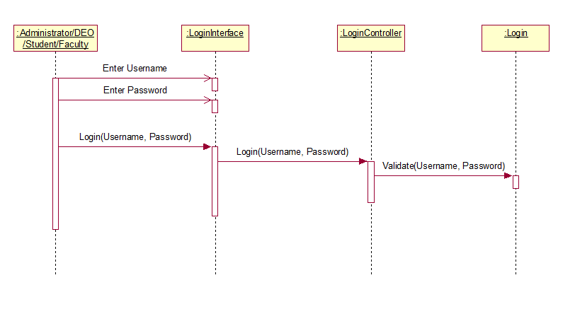

* 1. Alternate Flow

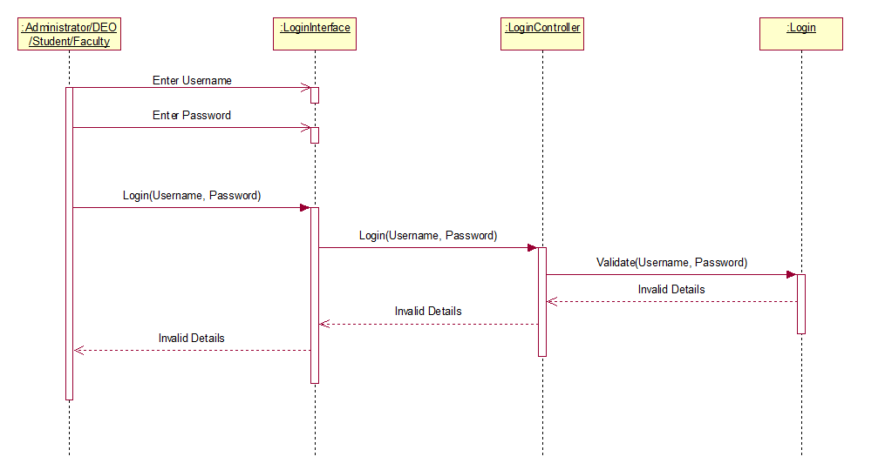

1. Maintain Student Details
   1. Add Student – Basic Flow

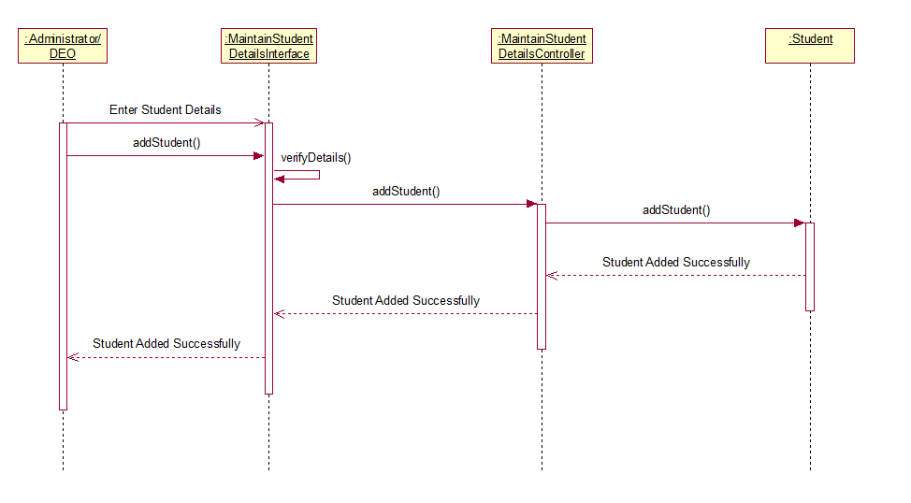

* 1. Add Student – Alternate Flow – Invalid Student Details

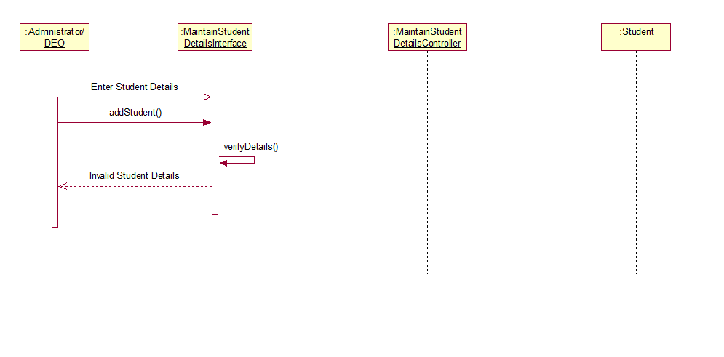

* 1. Add Student – Alternate Flow – Student Already Exists

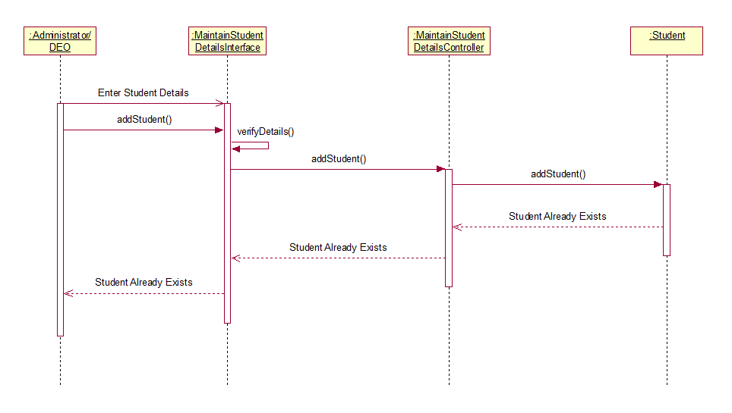

* 1. Delete Student – Basic Flow

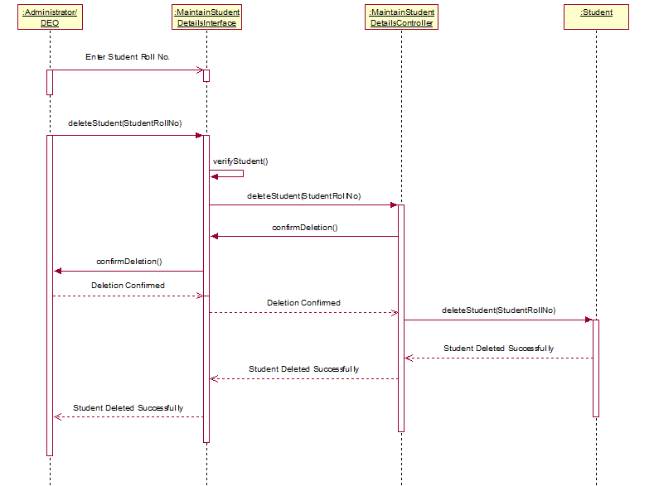

* 1. Delete Student – Alternate Flow – Student Does Not Exist

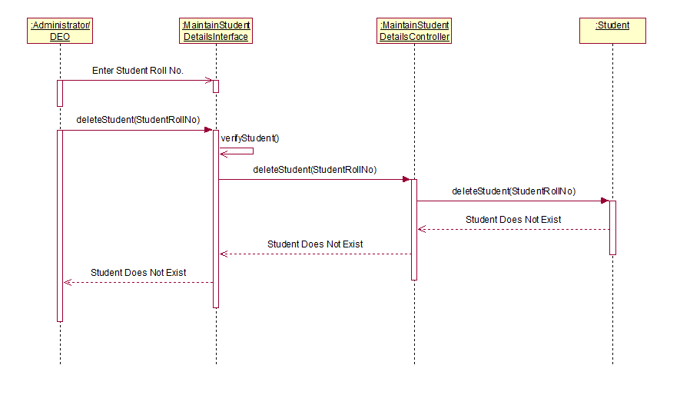

* 1. Delete Student – Alternate Flow – Deletion Cancelled

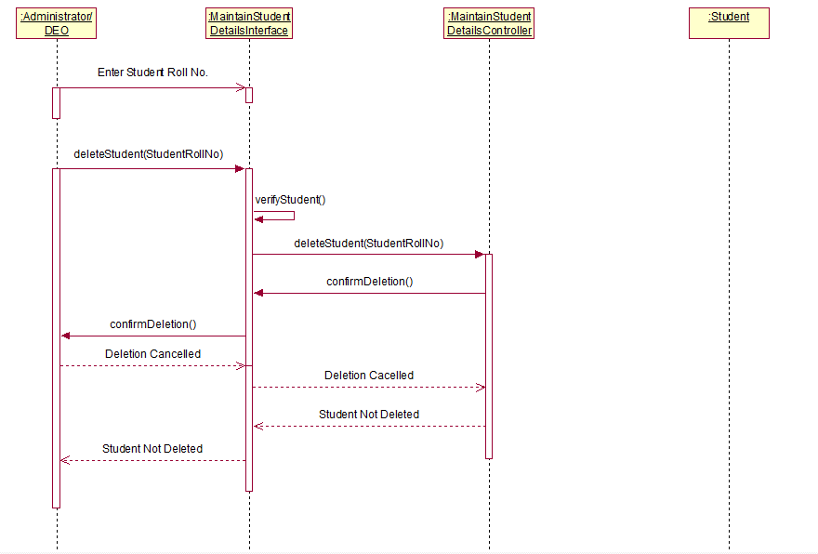

* 1. Update Student – Basic Flow

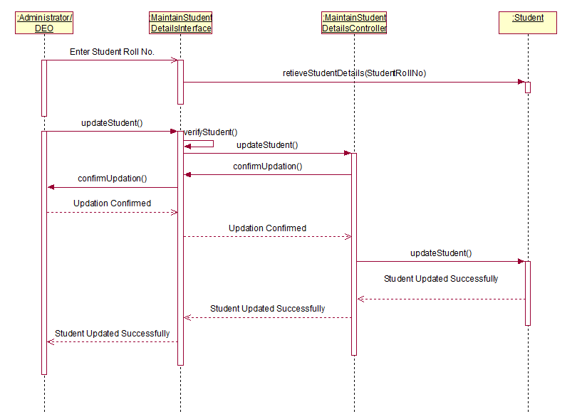

* 1. Update Student – Invalid Student Details

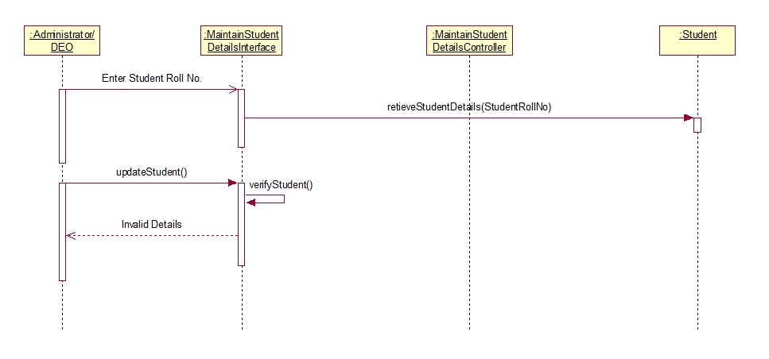

* 1. Update Student – Alternate Flow – Student Does Not Exist

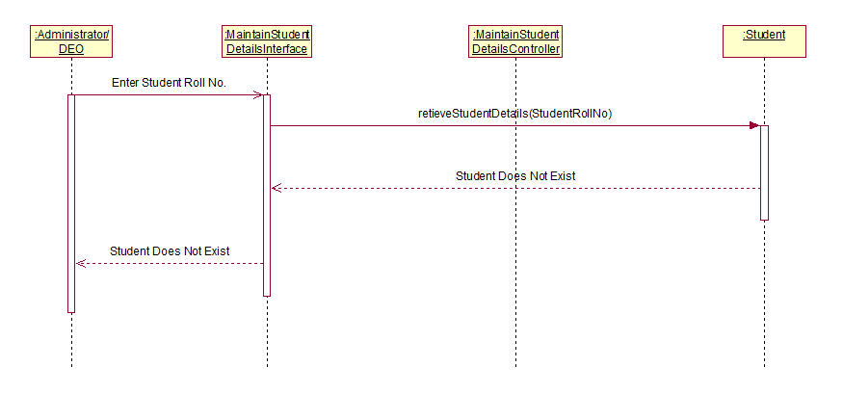

* 1. Update Student – Alternate Flow – Deletion Cancelled

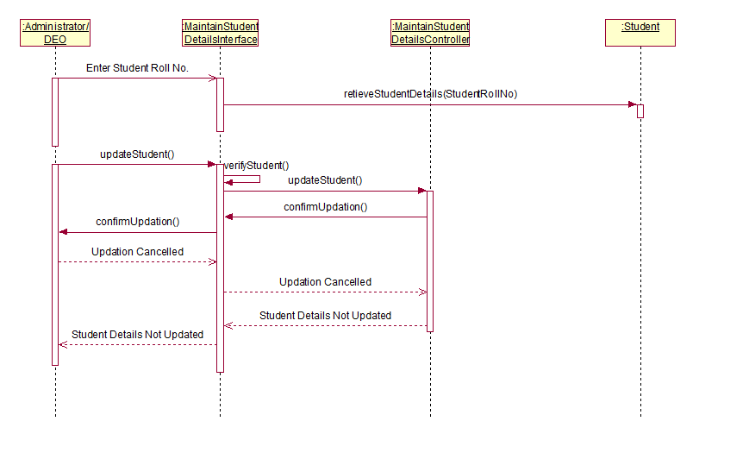

* 1. View Student – Basic Flow

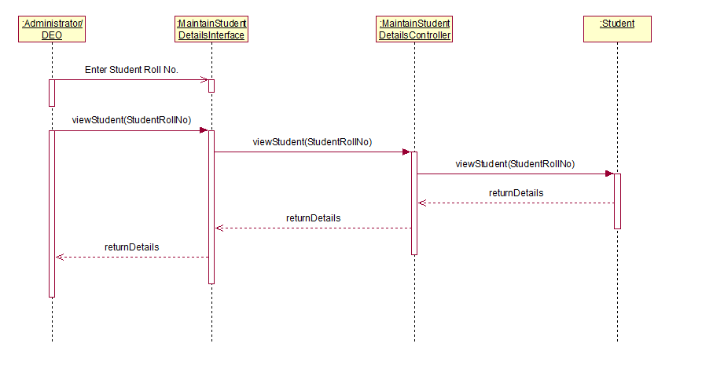

* 1. View Student – Student Does Not Exist

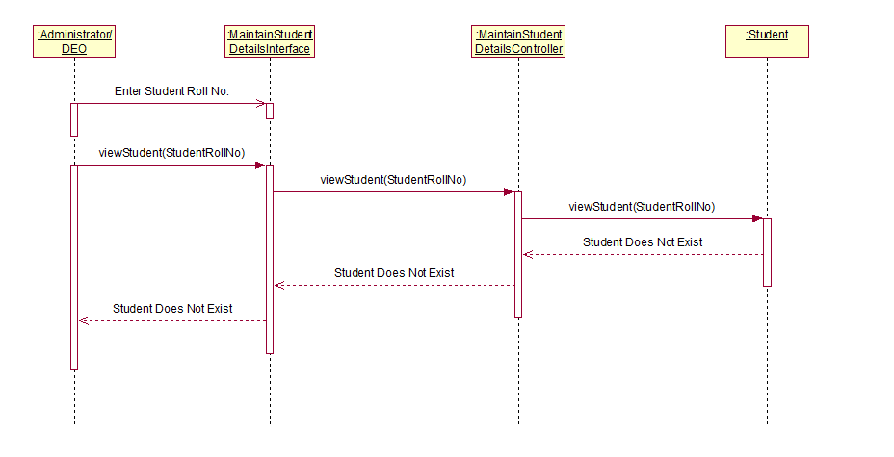

1. Maintain Faculty Details
   1. Add Faculty – Basic Flow

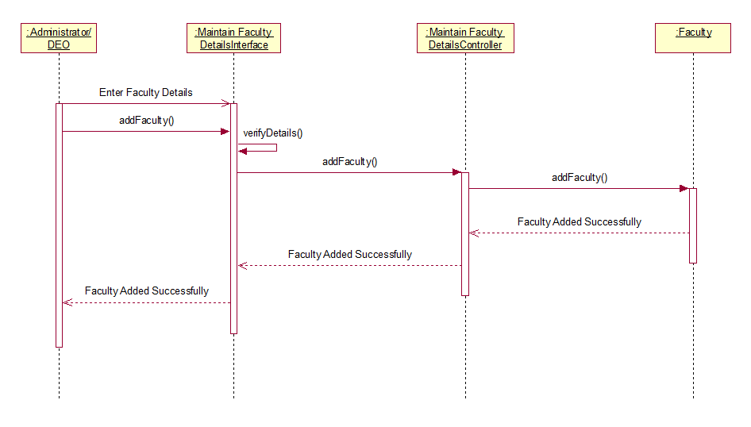

* 1. Add Faculty Alternate Flow – Invalid Faculty Details

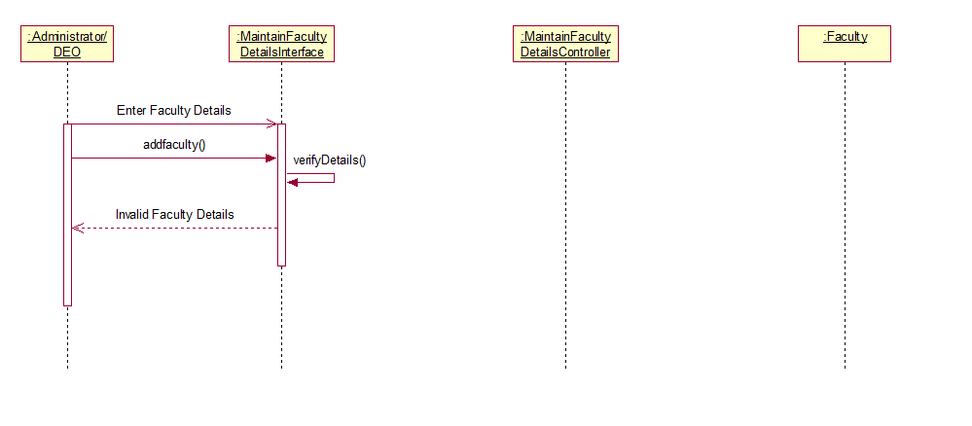

* 1. Add Faculty – Alternate Flow – Faculty Already Exists

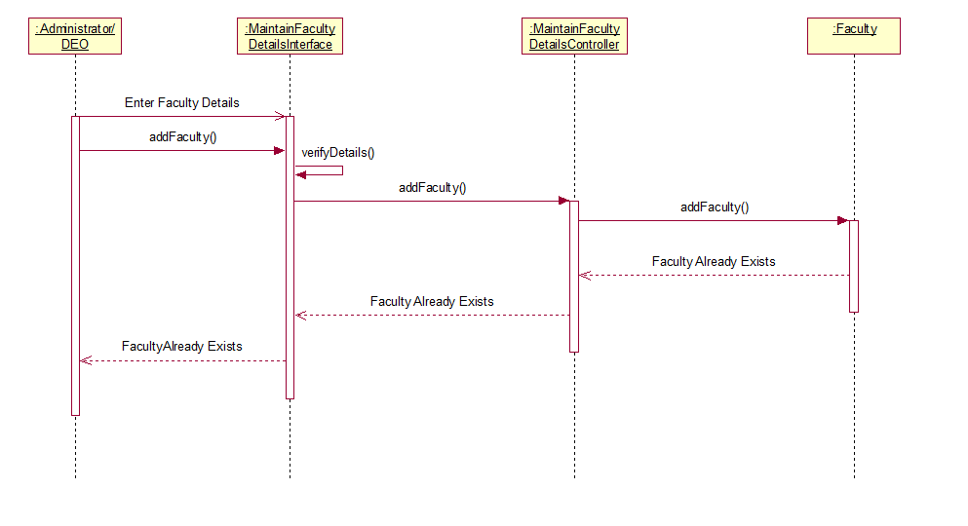

* 1. Delete Faculty – Basic Flow

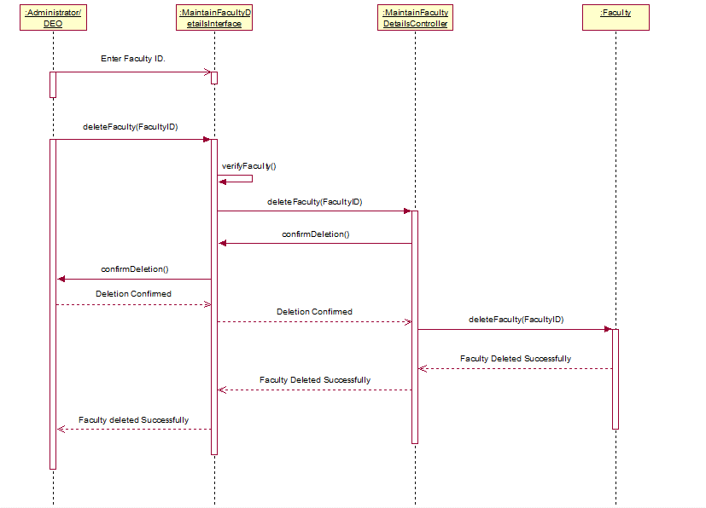

* 1. Delete Faculty – Alternate Flow – Faculty Does Not Exist

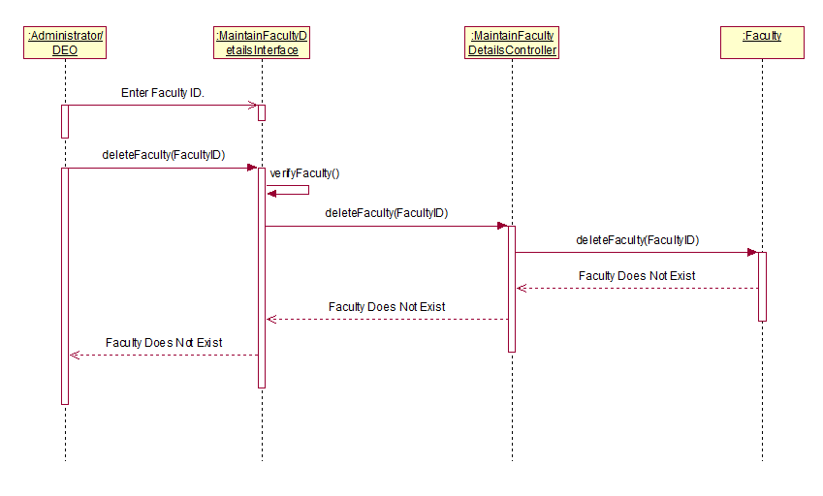

* 1. Delete Faculty – Alternate Flow – Deletion Cancelled

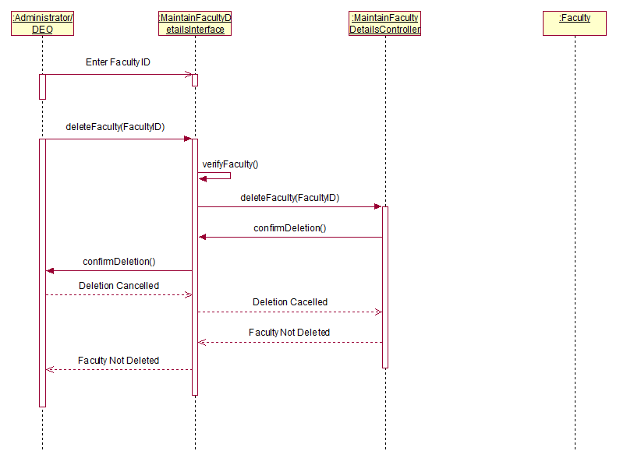

* 1. Update Faculty – Basic Flow

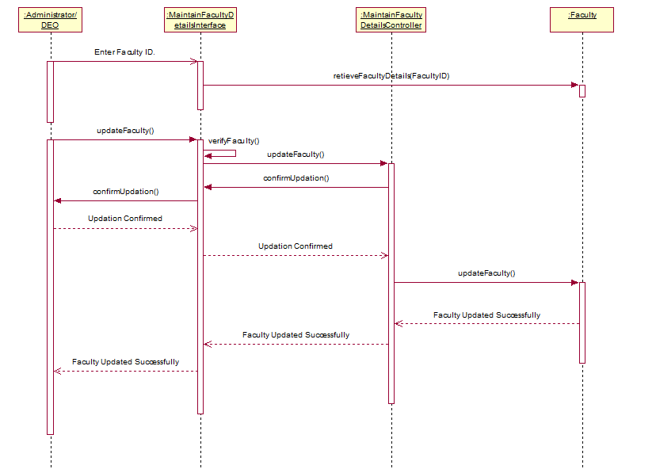

* 1. Update Faculty – Invalid Faculty Details

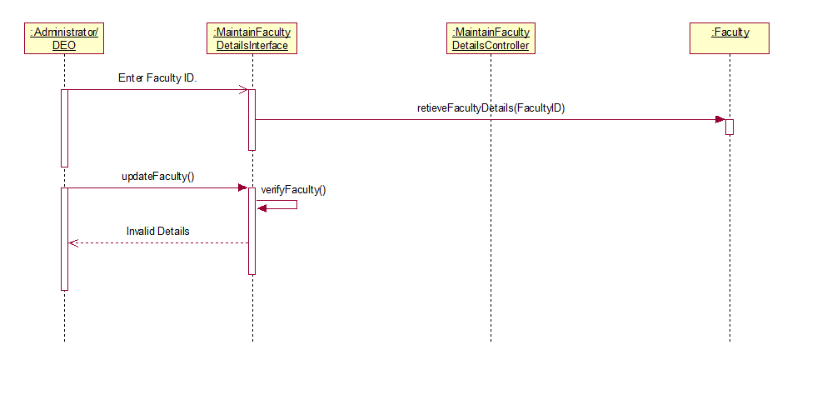

* 1. Update Faculty – Alternate Flow – Faculty Does Not Exist

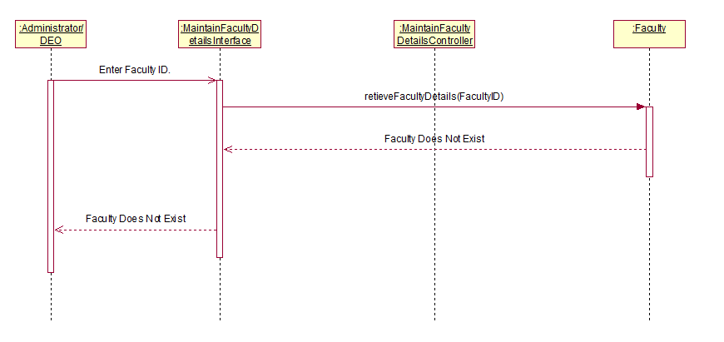

* 1. Update Faculty – Alternate Flow – Deletion Cancelled

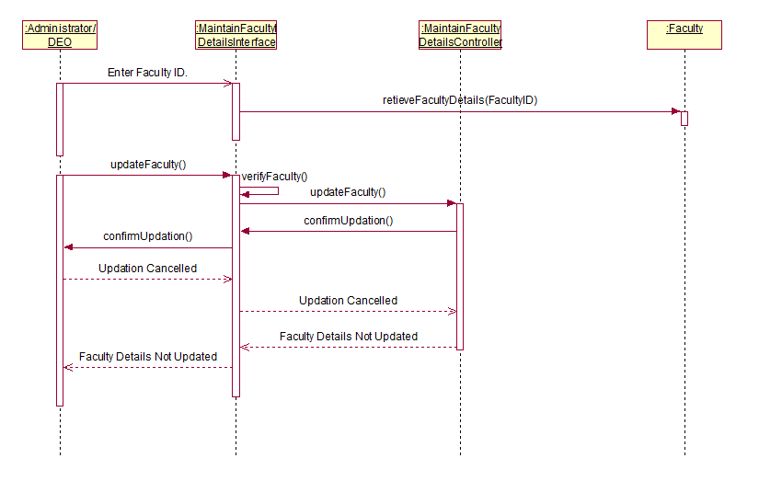

* 1. View Faculty – Basic Flow

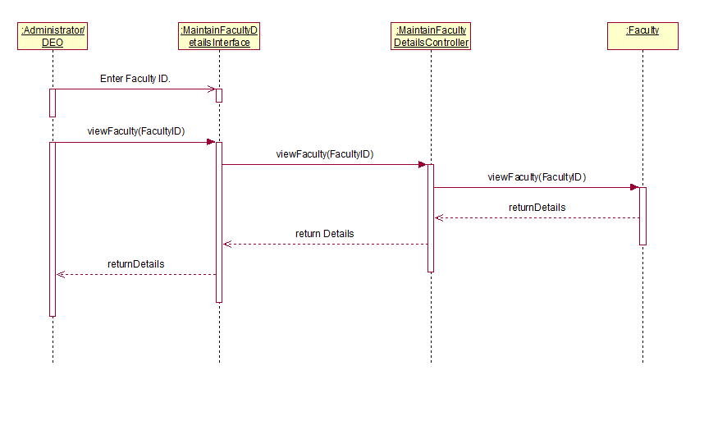

* 1. View Faculty – Faculty Does Not Exist

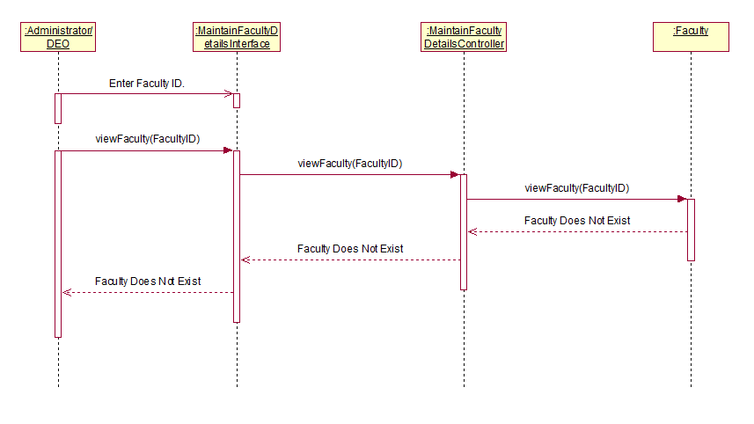

1. Maintain Department Details
   1. Add Department – Basic Flow

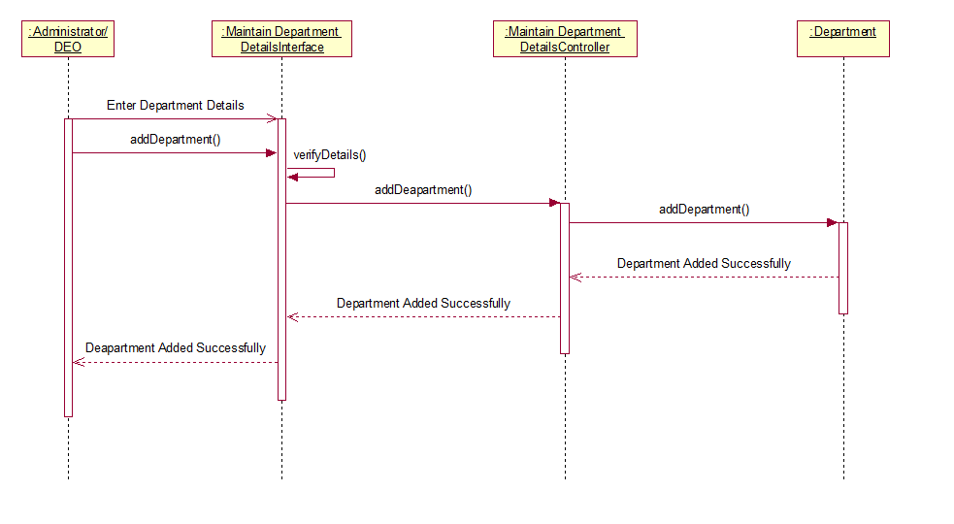

* 1. Add Department Alternate Flow – Invalid Department Details

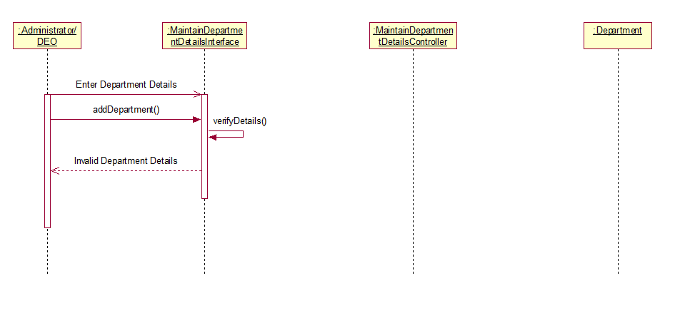

* 1. Add Department – Alternate Flow – Department Already Exists

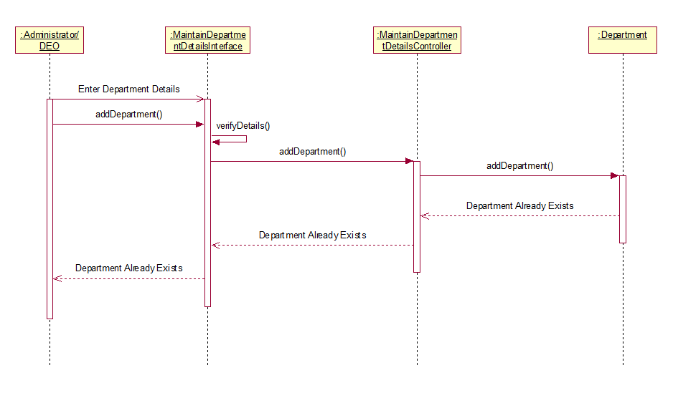

* 1. Delete Department – Basic Flow

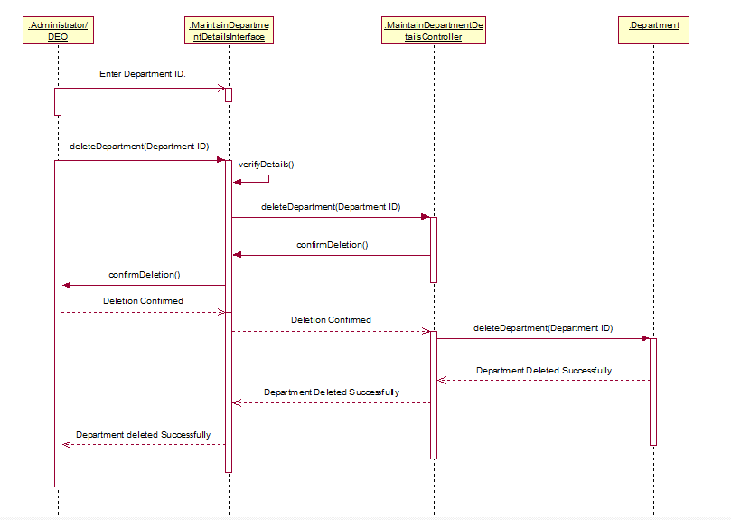

* 1. Delete Department – Alternate Flow – Department Does Not Exist

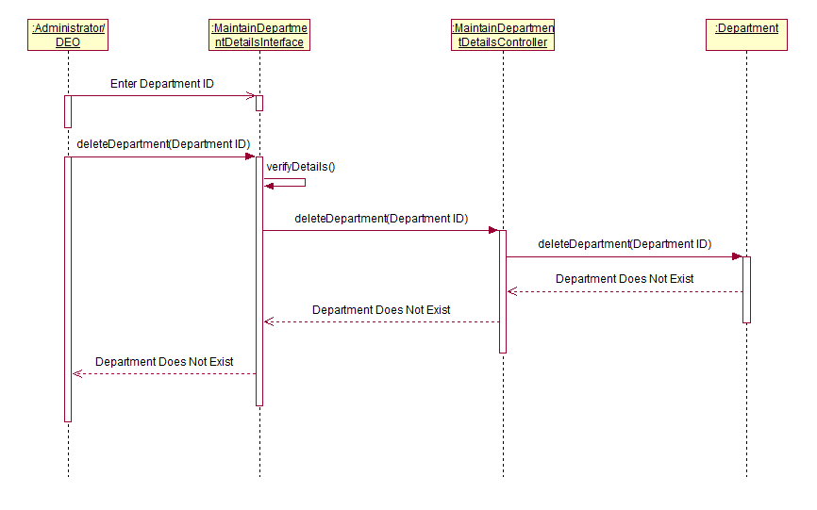

* 1. Delete Department – Alternate Flow – Deletion Cancelled

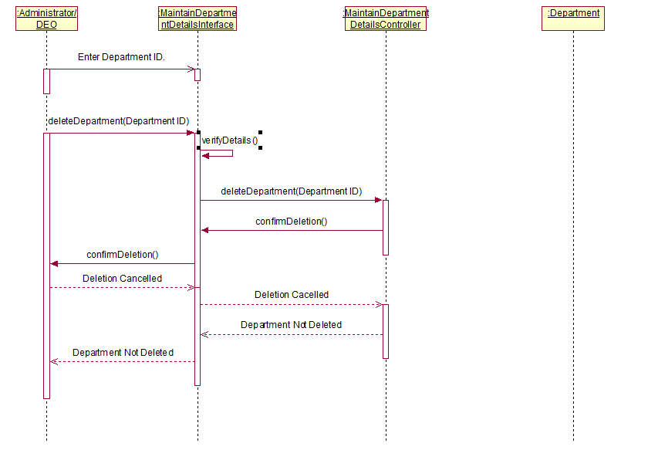

* 1. Update Department – Basic Flow

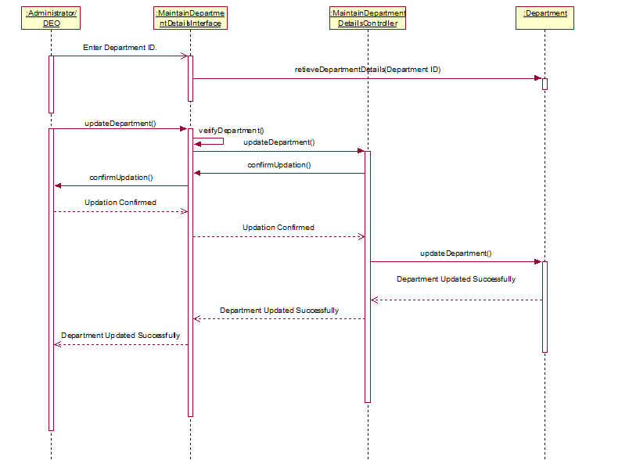

* 1. Update Department – Invalid Department Details

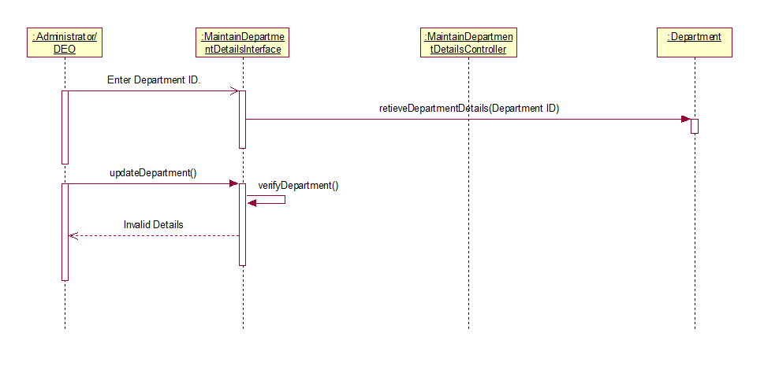

* 1. Update Department – Alternate Flow – Department Does Not Exist

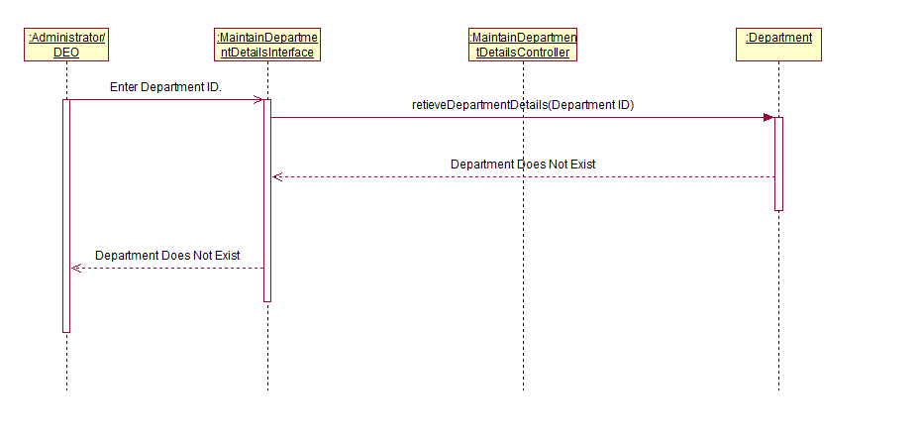

* 1. Update Department – Alternate Flow – Deletion Cancelled

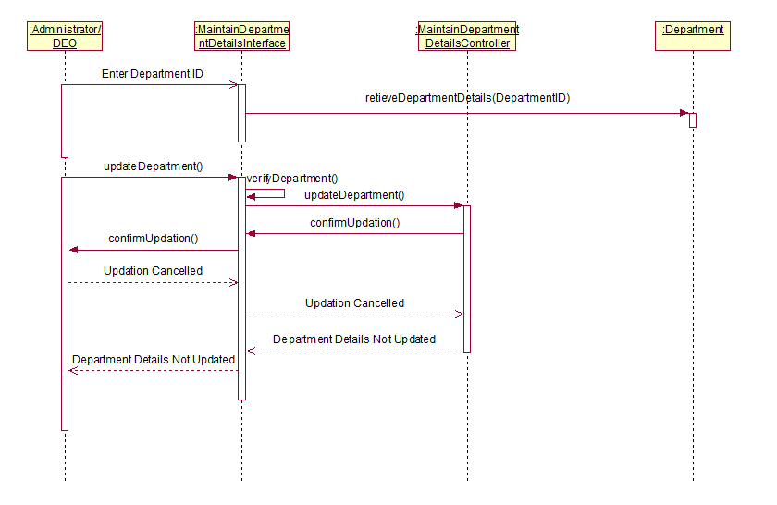

* 1. View Department – Basic Flow

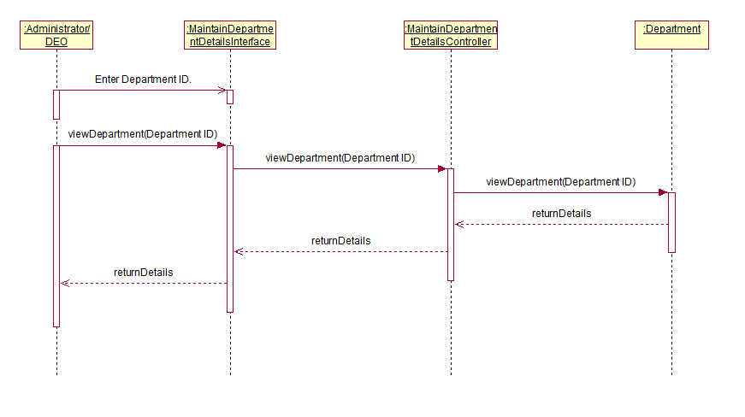

* 1. View Department – Department Does Not Exist

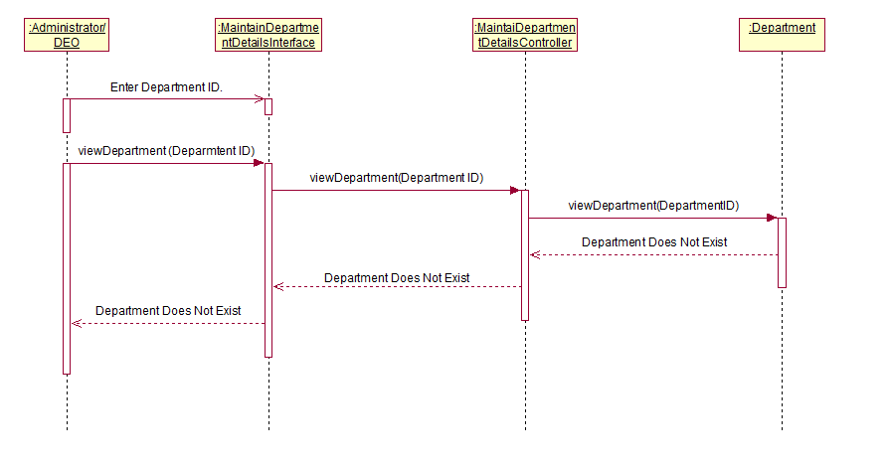

1. Maintain Branch Departments
   1. Add Branch – Basic Flow

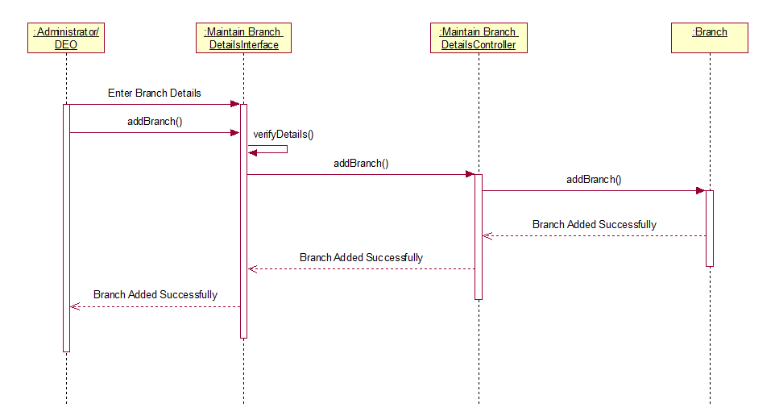

* 1. Add Branch Alternate Flow – Invalid Branch Details

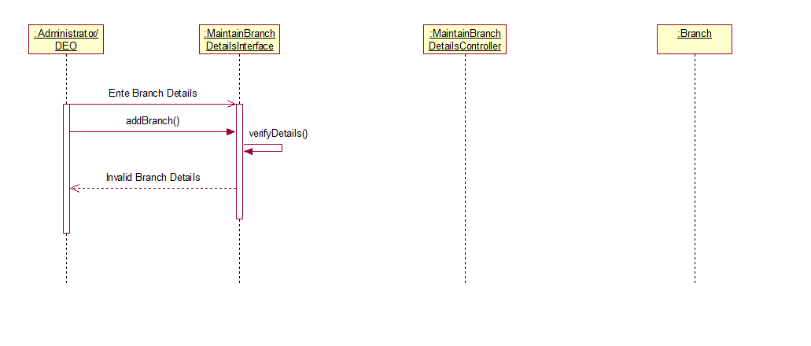

* 1. Add Branch – Alternate Flow – Branch Already Exists

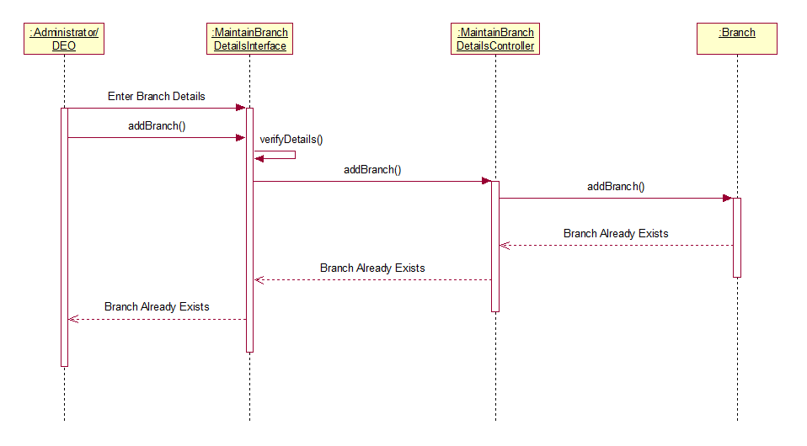

* 1. Delete Branch – Basic Flow

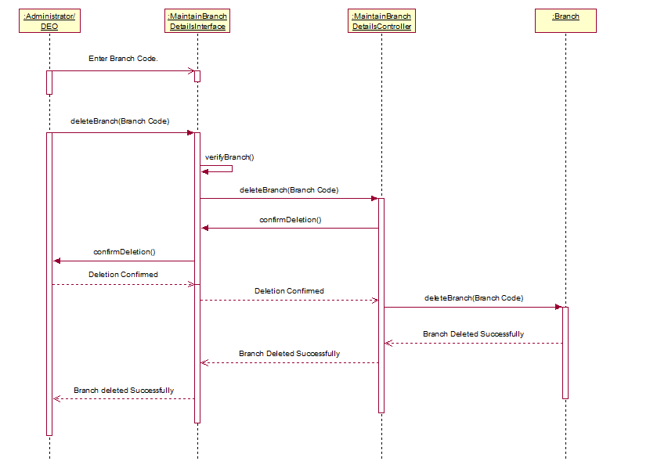

* 1. Delete Branch – Alternate Flow – Branch Does Not Exist

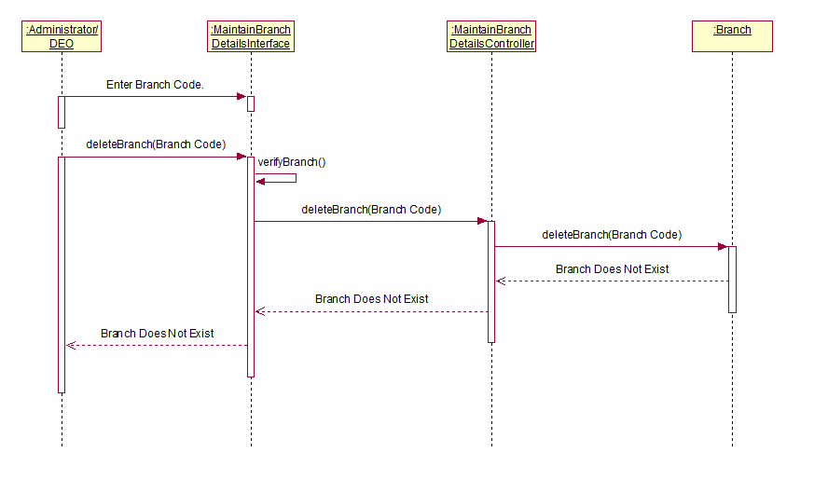

* 1. Delete Branch – Alternate Flow – Deletion Cancelled

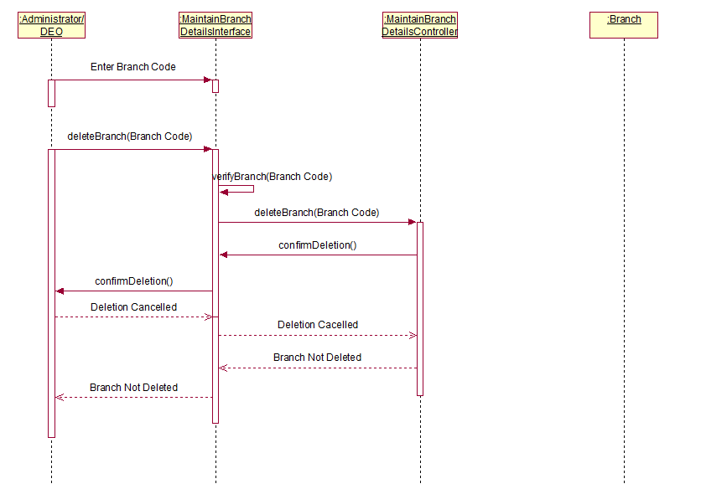

* 1. Update Branch – Basic Flow

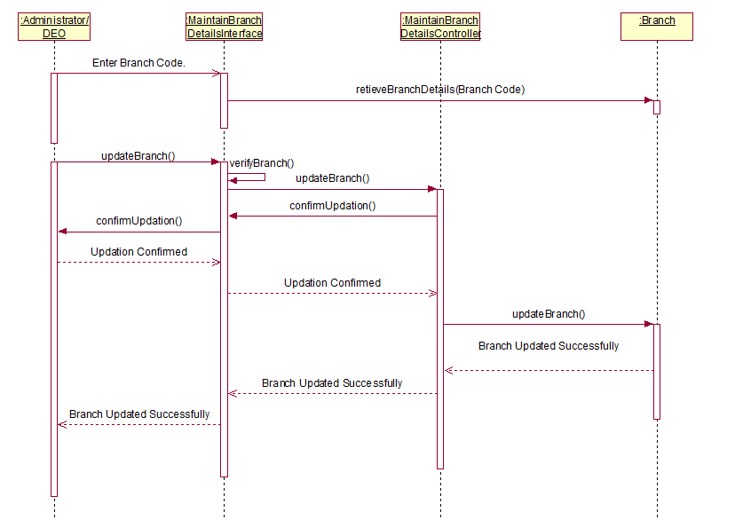

* 1. Update Branch – Invalid Branch Details

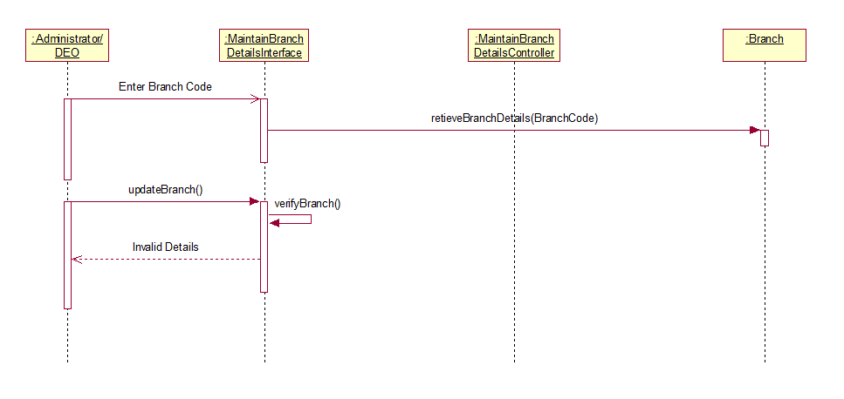

* 1. Update Branch – Alternate Flow – Branch Does Not Exist

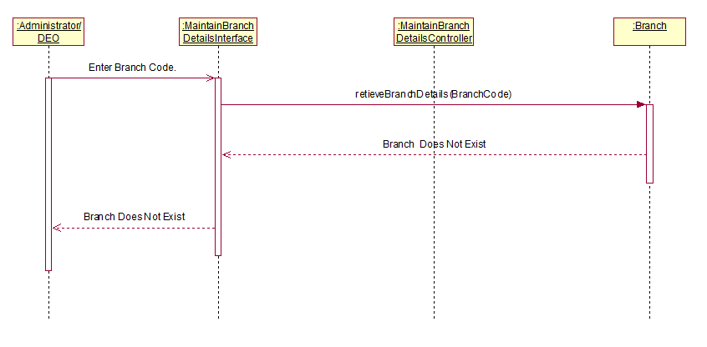

* 1. Update Branch – Alternate Flow – Deletion Cancelled

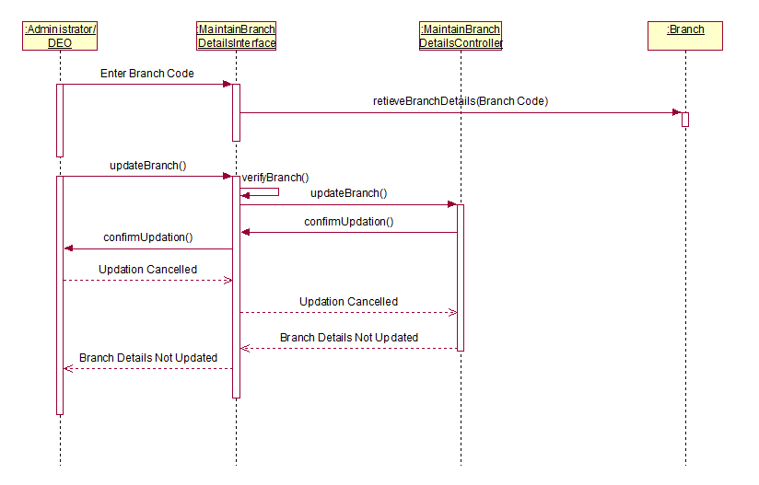

* 1. View Branch – Basic Flow

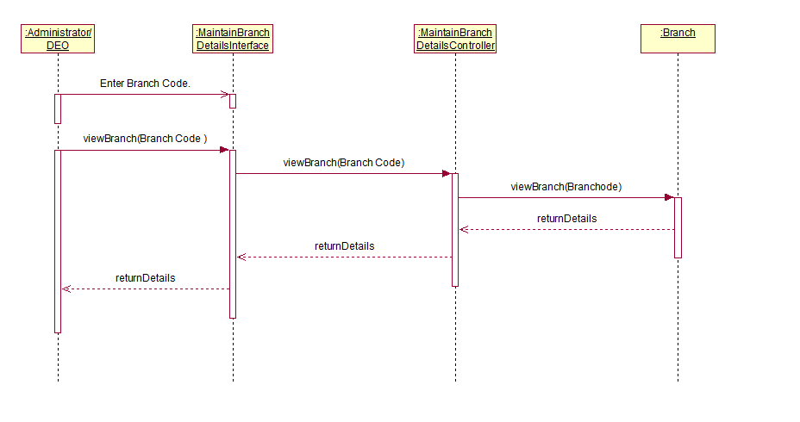

* 1. View Branch – Branch Does Not Exist

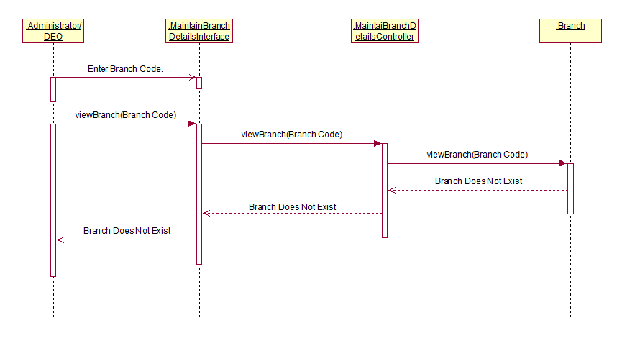

1. Maintain Course Details
   1. Add Course – Basic Flow

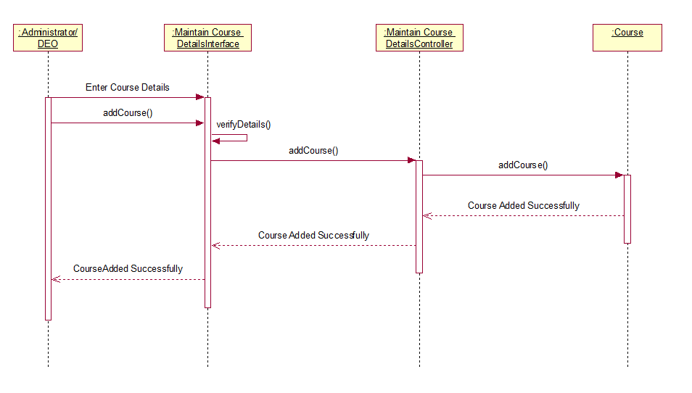

* 1. Add Course Alternate Flow – Invalid Course Details

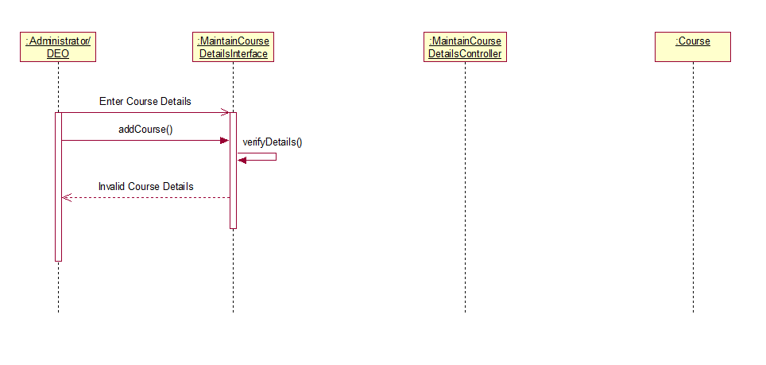

* 1. Add Course – Alternate Flow – Course Already Exists

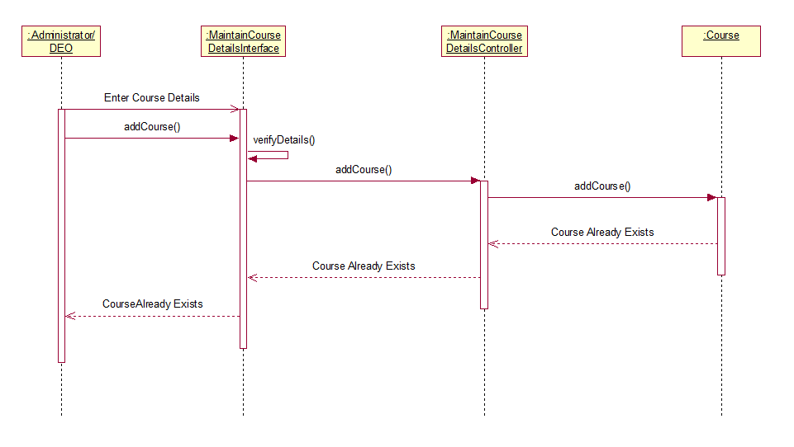

* 1. Delete Course – Basic Flow

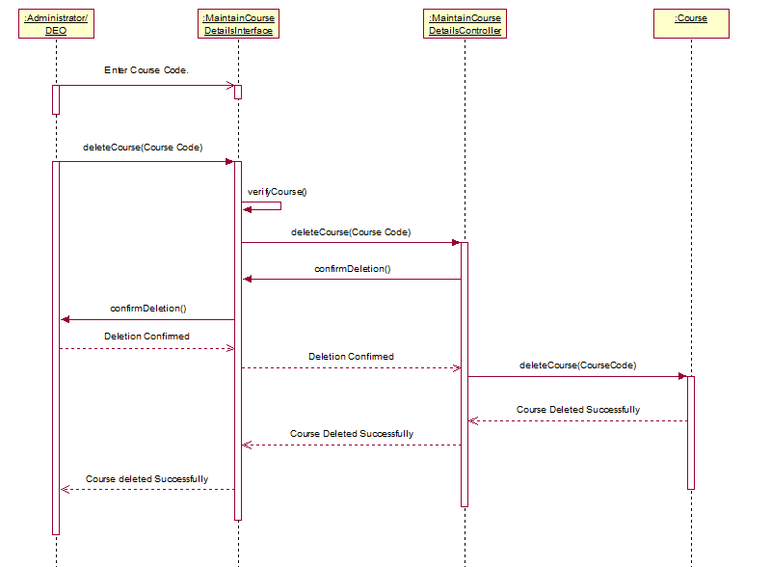

* 1. Delete Course – Alternate Flow – Course Does Not Exist

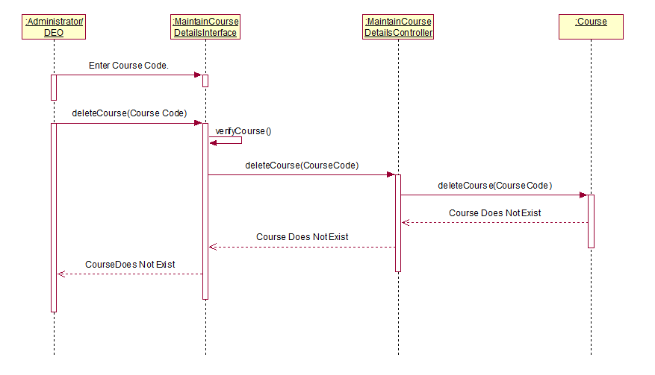

* 1. Delete Course – Alternate Flow – Deletion Cancelled

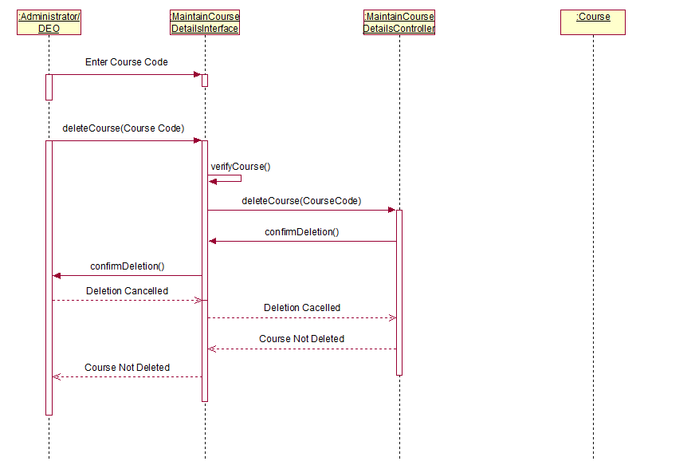

* 1. Update Course – Basic Flow

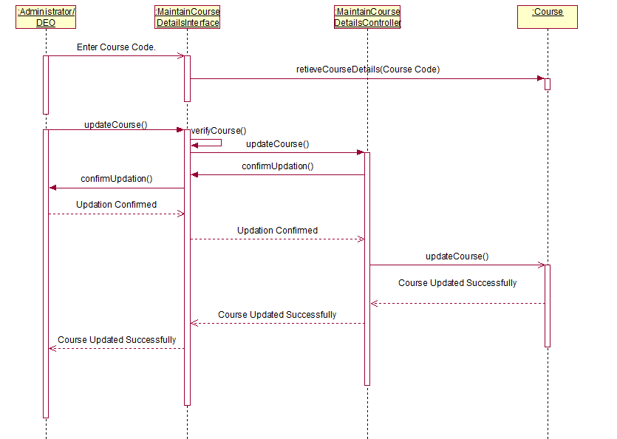

* 1. Update Course – Invalid Course Details

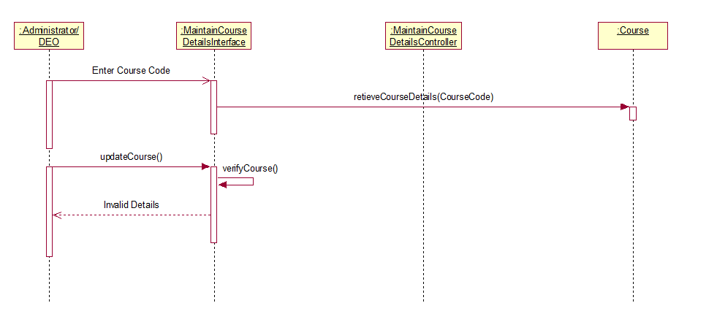

* 1. Update Course – Alternate Flow – Course Does Not Exist

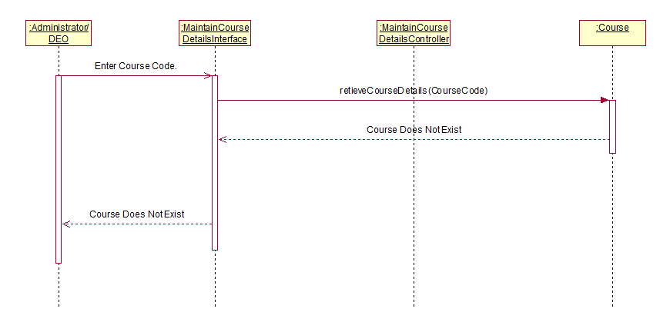

* 1. Update Course – Alternate Flow – Deletion Cancelled

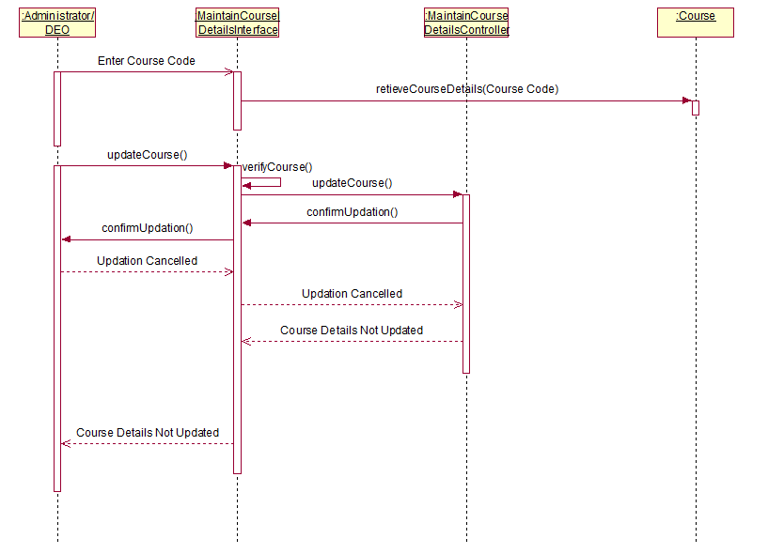

* 1. View Course – Basic Flow

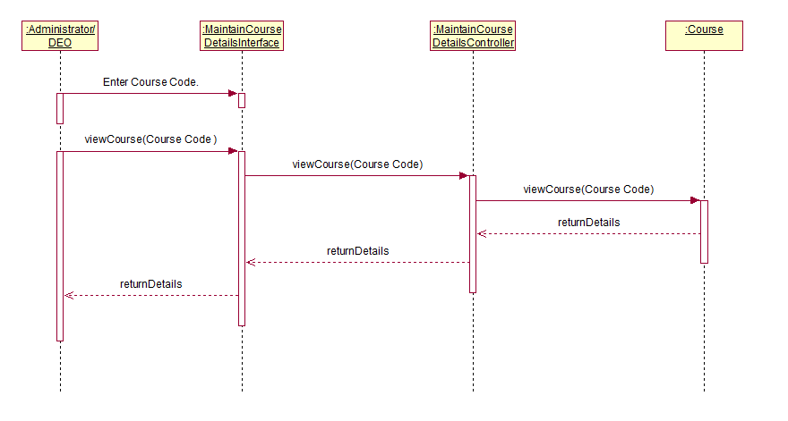

* 1. View Course – Course Does Not Exist

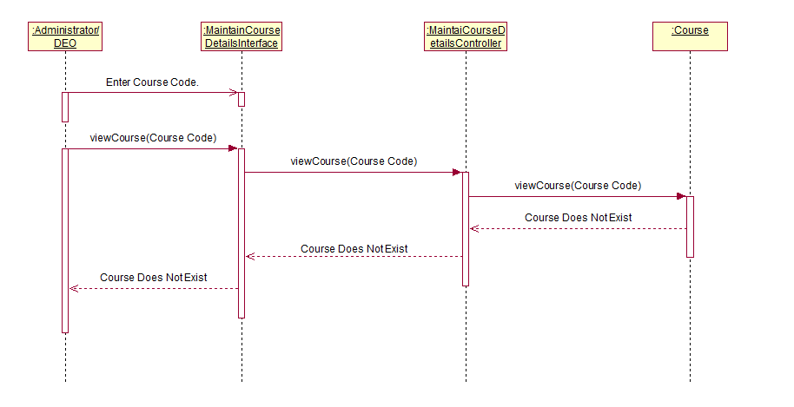

1. Search Department
   1. Basic Flow

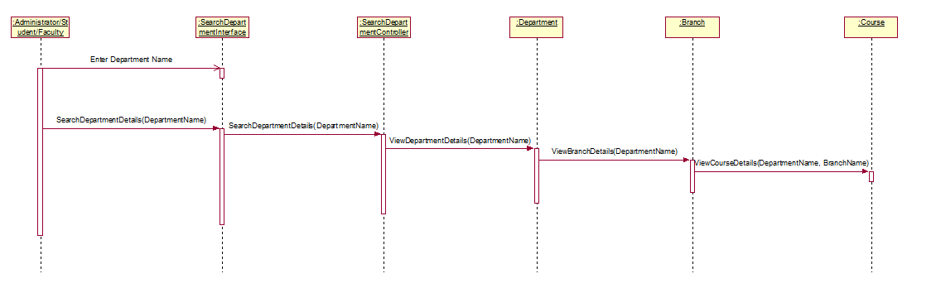

* 1. Invalid Department Name

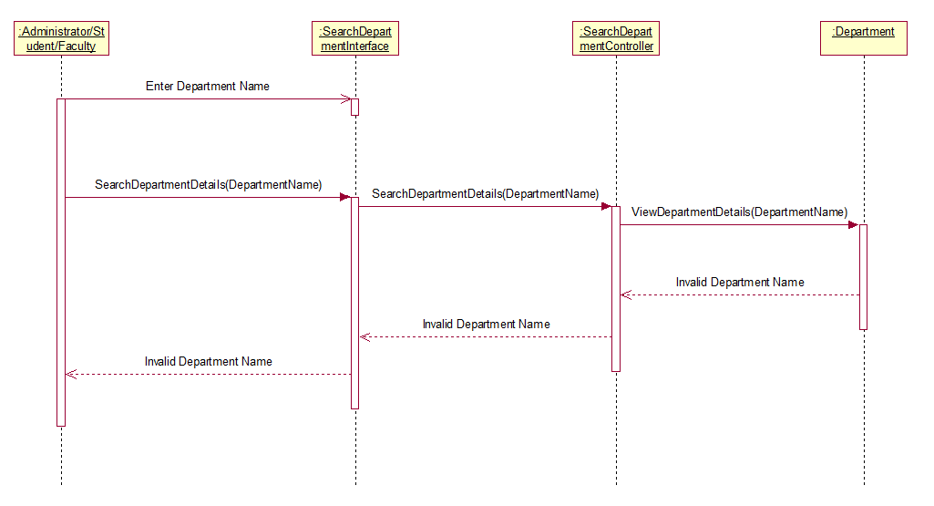

* 1. Department Details Available

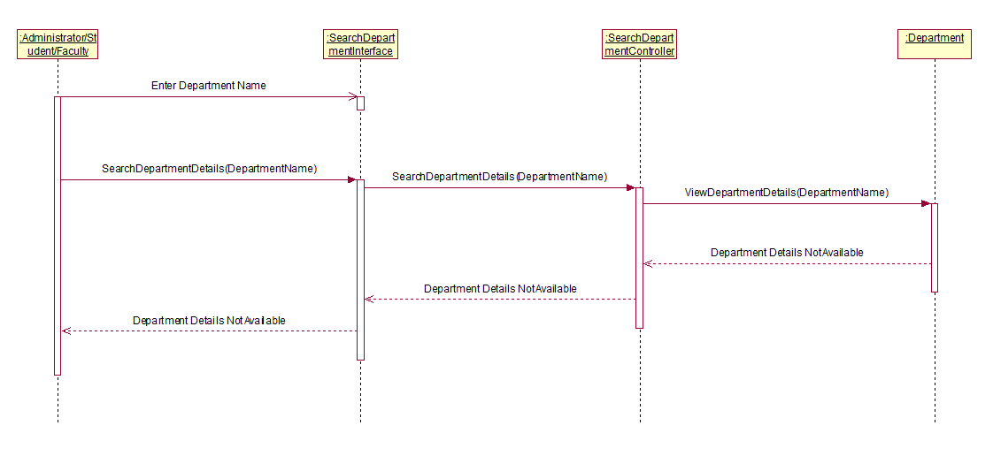

1. Search Time Table
   1. Basic Flow

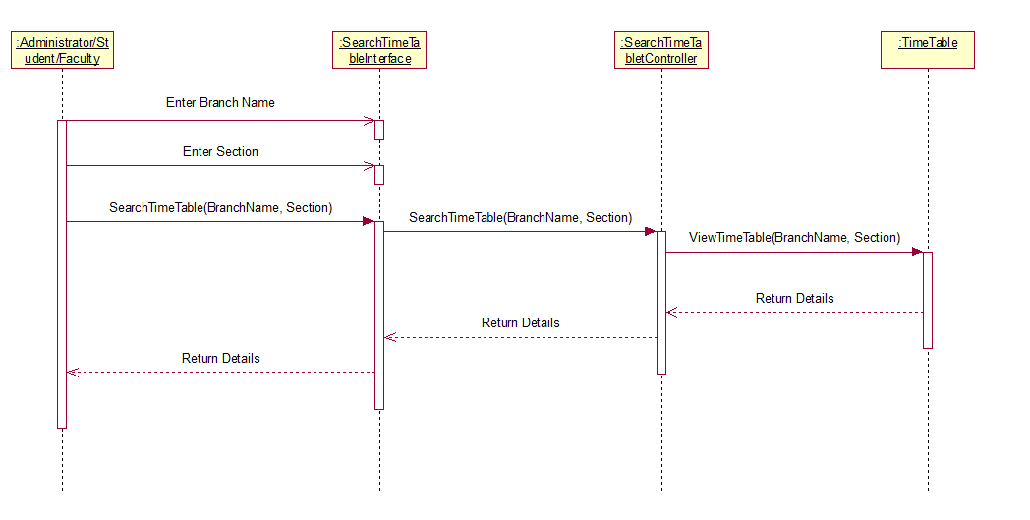

* 1. Invalid Details

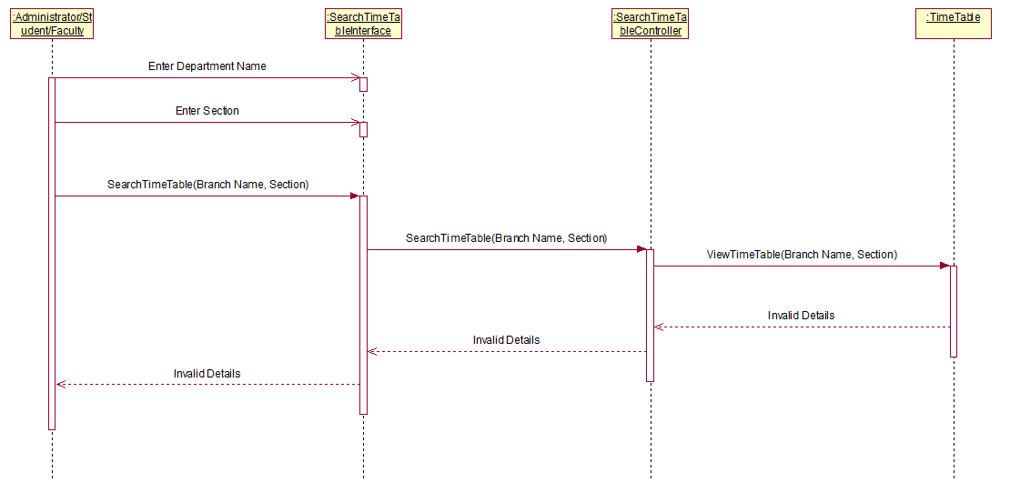

* 1. Time Table not available

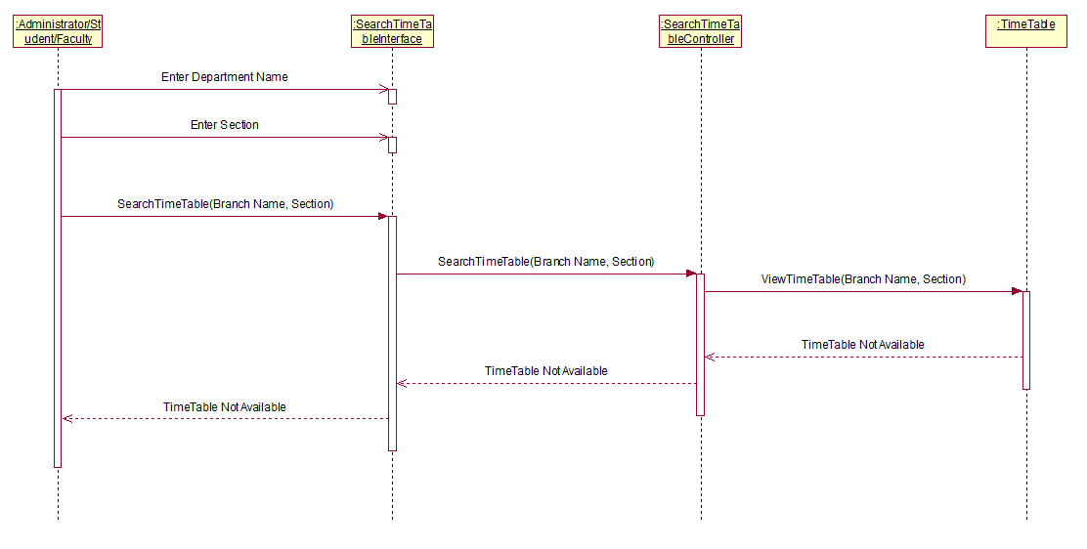

1. View Time Table
   1. Basic Flow

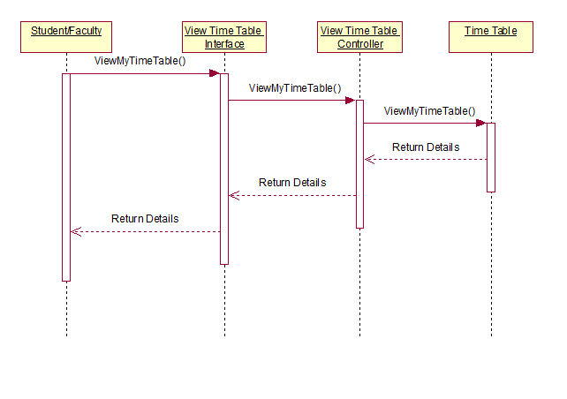

* 1. Time Table Not Available

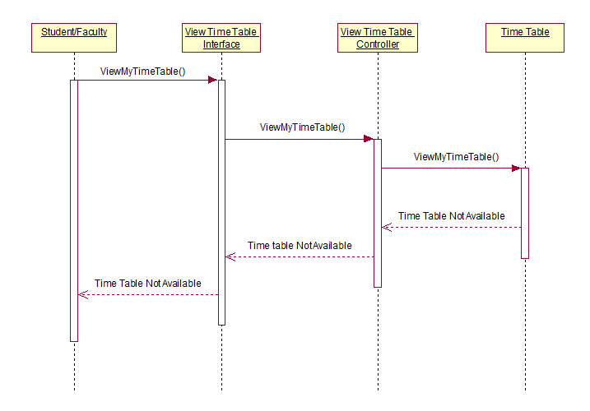

1. Course Selection
   1. Basic Flow

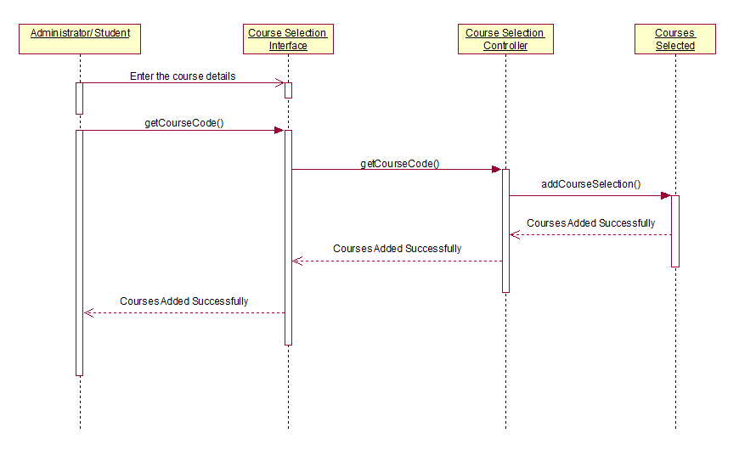

* 1. Invalid Details

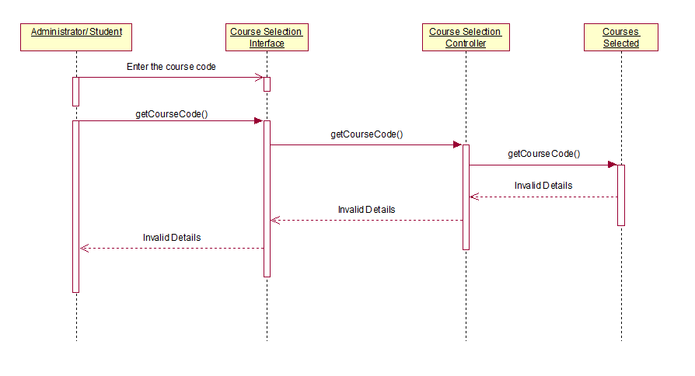

1. View Enrolments
   1. Basic Flow

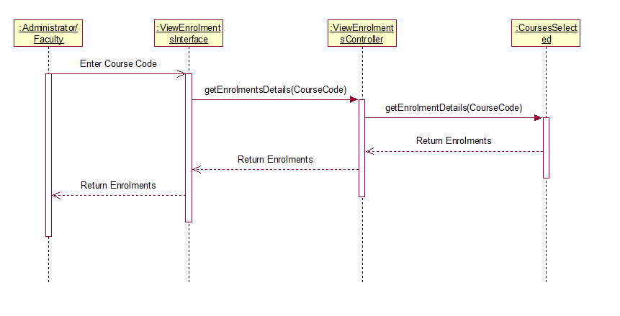

* 1. Course Not Found

